Standard 5: Impact on Student Learning
Element: 5.3 Utilize the reflective cycle to implement change in the teacher performance, student learning, and instructional goals and decisions.

Artifact: EDU 355 Reflective Log
Date: Spring 2012

Reflection: This is a copy of the reflection log I wrote after teaching a lesson in my elementary host school. My partner and I created a pre-assessment checklist for the cartwheel. We pre-assessed the students, and according to the results planned a lesson to teach. At the end of the lesson we held a post-assessment of the cartwheel to see if learning took place. Being able to reflect on a lesson will help me in creating better plans for the future. Not each lesson will go perfectly, so it is important to reflect and change teacher performance and management skills to enhance student learning. These constant and qualitative reflections have guided me in planning more efficient lessons. Planning, creating, and teaching valuable lessons will build a higher impact on student learning. Knowing how to have an impact on student learning is important for my career because by truly influencing the students, physical education can lead to life time enjoyment of activities.

Field Experience Day 13

April 3rd 2012
Elementary School - 2nd grade
TOPIC: Assessments of student learning
Prior to teaching this lesson, my partner and I collected pre-assessment data on the cartwheel. We then took the results and planned accordingly to teach specific cues for the students to enhance this performance. In this class my partner and I used the same psycho-motor assessment checklist at the end of our lesson to see if learning occurred. We started the lesson off with a thorough explanation of the cartwheel including the cues and pictures step by step. I made sure they all knew that by the end we were going to assess them on their cartwheel and to pay close attention to each activity explained. From our pre-assessment data we split the students into two groups. Group 1 contained the students who could successfully perform the cartwheel, and group 2 held the students who needed more direction and practice. Group 1 went off with my partner to rotate through the other stations of the gymnastics unit. I took group 2 and we started off with some progressions of the cartwheel.

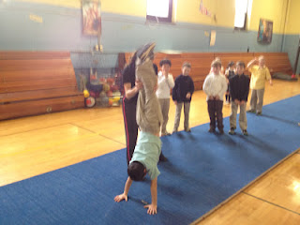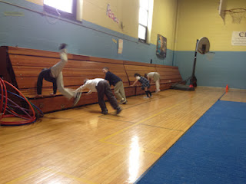

What I started to notice was that the progressions I choose were too advanced for the level the students were starting at. It almost turned into a mess! I was very nervous for safety issues. The progressions I had planned in my lesson turned totally wrong during the class. I realized I should have started at the complete beginning for these students. I needed to go back to the very basics of a cartwheel in order to boost up the confidence levels of the students who were afraid to try. I tried to figure out how to fix the problem before any safety concerns occurred. I brought the group in and we re-explained the cues. In the moment it was difficult for me to think of smaller progressions to teach the students. I assumed my organization strategies would go as planned, which was not the case. My host teacher helped and we came up with a new task to focus on, ultimately giving the students a better understanding of the cartwheel. I wish the class time was longer so I could have continued teaching once I finally started the better progression.
Reflecting back on this lesson, I recognize that I should have gone straight to a source who has taught young children progressions of a cartwheel. As a teacher, I do not think it is bad that my lesson went wrong; it actually has helped me in implementing a change in my teacher performance. It is important to always have a backup plan. Student learning will be the most significant part of my career. In the end, only two students went from a no to a yes on the checklist. However, a handful of students did improve in certain critical elements. When it comes to instructional goals I need to plan accordingly to the age I will be teaching. If I learned one thing from this lesson, it is that all students are defiantly at different levels, especially in an area such as gymnastics. I believe I was able to act quickly in order to gain control over the class and redirect them in a different task. I enjoy reflecting on each lesson in order for me to continue learning and growing as a teacher. The only way to get better is through practice. This lesson gave me determination to create better lessons for my students.

