Standard 3: Planning and Implementation
Element: 3.3 Design and implement content that is aligned with lesson objectives.

Artifact: Basics of Effective Instruction in P.E. Lab D, Resource Project
Date: Fall 2011

Reflection: This artifact demonstrates my ability to design and implement a unit based on a topic that was new to me. The artifact shows how I was able to create a lesson, as well as a whole resource packet aligned with the topic of water aerobics. My lesson objectives for the students became the focus while designing my progressions and block plan. This was important to my development as teacher because the act of aligning objectives to the content will be a challenging part of my career. Practice in this area helped me discover effective ways in planning content that associated with what my goals for the students were. It is important to understand that designing lessons in context with lesson objectives will not come easy as a reflective teacher. Being able to constantly update my lessons is essential to meet the needs of my students.

Water Aerobics
Resource Packet
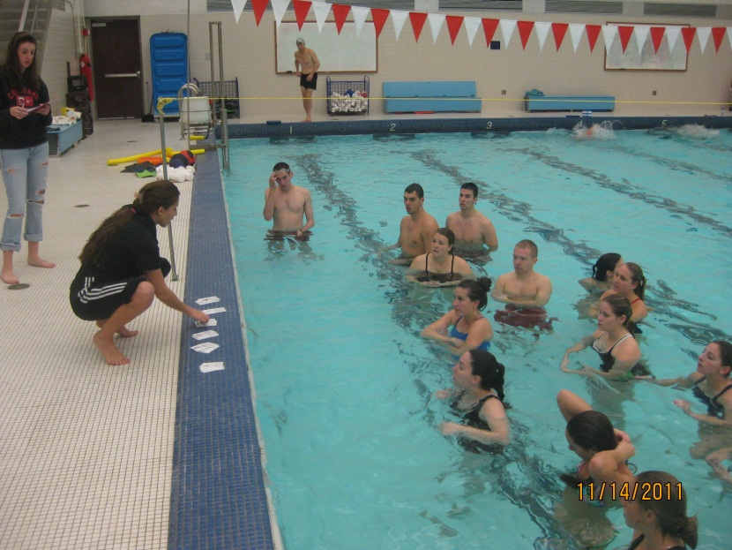

Ms. Fredrickson
10th grade –
Section 604 FALL 2011

History of Water Aerobics

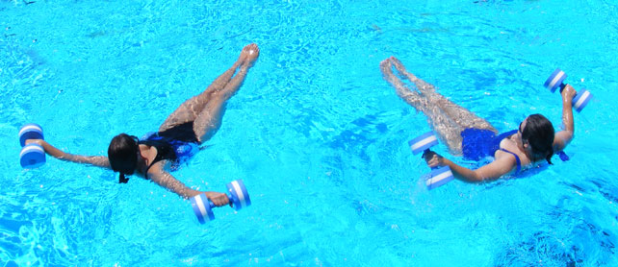

Water aerobics, or aquatic exercise, is a fitness program that takes place in the pool. The workout is to help you raise your heart rate and breathing to get the benefits of a cardiovascular workout without placing stress on muscles and joints. The water is usually waist or chest deep and helps your body to move despite the resistance of the water. In the 1950’s water aerobics was practiced by television fitness professional Jack LaLane. The benefits of aerobic exercise became known to have great health benefits and aquatic aerobics became popular during the 1970s and 1980s. In the early days of water aerobics, all you needed was an elementary level of fitness, the basics of swimming, a bathing suit and a swimming pool. Swim caps and nose plugs were optional. Now there are many variations in what classes can entail, from therapy to overall fitness and from beginning to expert levels. Water aerobics classes started to become more structured which includes a 10 to 15 minute warm-up period. Next would be an estimate of 20 and 30 minutes of vigorous exercise underwater movements such as walking, jogging and upper-body motions designed to get your heart pumping. That part of the class is usually followed by a 15 to 20 minute cooling-down period. Tools for today's water aerobics might include water shoes, water weights and/or flotation devices. Overall water aerobics have proven to be a great workout that is safe and obtainable for all ages and body types.

Fun Facts
- Water resistance increases strength and helps with toning, firming, endurance, burning calories and relieving stress in joints.
- One hour of water aerobics burns between 450 and 750 calories without overheating your body or producing muscle soreness afterward.
- It also builds cardiovascular health and increases your metabolism sufficiently for you to lose weight.
- Walking on land for half an hour at an average pace burns approximately 135 calories. Walking in chest-deep water for the same length of time burns nearly twice as many calories
- When you are in water up to your chest, the weight of your body is reduced by over 80 percent, making it easier to move around.

Behavior Plan

-Begin lesson promptly: In order to get the students interested and have control I do not want to have any delays.
-Be enthusiastic: If teaching appears to be a chore, students hardly can be expected to relish the experience. Stay positive and loud.
-Be alert: Constantly cultivate total class awareness.
-Do not compete with noise: I will make it clear that I will give everyone the opportunity to talk, but expect the same consideration. Pause until the students become attentive.
-Communicate the expectations: Cleary communicate the expectations in all ways for the class and then actively insist that the expectations are met. This will not be in a threating manner.
-The look: Watch and observe students behaviors. They will know if you are looking at them and hopefully can see what the look is implying.
-The touch: Simply walk by a student who is misbehaving and touch their shoulder. This will help them understand their behavior has not been unnoticed.
-Offer a warning: Let the student know that the behavior is not acceptable and this is his warning.
-Take 2 minutes: If a student cannot control themselves after all of the above, ask him/her to take 2 minutes and walk the parameters of the gym to gain control. Explain that after 2 minutes they may join the class again, however if they need more time to take it. They cannot be sitting, they must be walking.

In the pool – If any student decides to wonder out of the three lanes we have, warn them once. If they continue to misbehave and disrupt the others in the pool area, ask them to come up onto the deck and perform the skills alongside with me. The same will go for any other behavior issues. Once they continue misbehaving after a warning, have them come next to me on the deck to ensure they are on task. Separate any students who are splashing, arguing, or being disrespectful. Be aware of these students and keep a close eye.

CLASS RULES POOL RULES during Water Aerobics
- Be kind 1. NO running
- Please and Thank you 2. NO diving
- Raise your hand 3. NO deep end
- Stay in self-space 4. NO splashing
- Listen for whistle 5. Respect others in pool
- Encourage your teammates 6. Stay in self-space
- Keep your hands to yourself 7. Keep your hands to yourself
- Stay focused 8. ALWAYS listen
- Give it your all! 9. Give it your all!
- Stay positive 10. Stay positive

Technology: Tabata Training
Tabata Training: A new workout method created and tested to be highly effective. Tabata was founded in Japan by Izumi Tabata. He performed tests with results showing that the athletes training in high intensity interval training enhanced their aerobic as well and anaerobic systems. And the athletes that used moderate high intensity training only improved their aerobic system and had little to no increase in their anaerobic system.
Tabata training has 4 minute long sessions with 20 seconds of intense training, 10 seconds of rest, and a total of 8 intervals.

Technology: On the new popular electronic device the iPad everything is done with the fingers, from surfing the internet to writing an email, reading a book or viewing photos. It has many of the same features of an iPhone with many applications and choices to use it for. On the iPad you can purchase a specific application that is for Tabata training. The Tabata timer is a device that will help you maintain the proper interval during your Tabata workout. For an example if your workout happened to be running, you would run absolutely as fast as you possibly can in an all-out sprint for 20 seconds. When your time is up, you would rest for 10 seconds. Repeat this cycle 8 times. This technology ensures proper workout time for each interval and session.
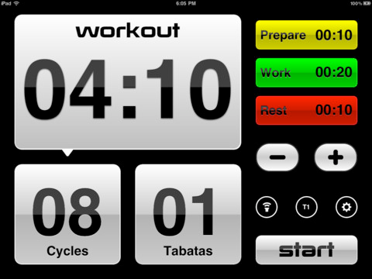

Enhance Learning: The great thing about this training is that it incorporates a faster way to get a workout done. For students and young adults it is harder for them to truly stick to a work out plan due to lack of time. If students learn about this new type of training, and realize it can save them time, it could be highly beneficial for them. The application is a great way to motivate and keep a person right on task. It blinks green very fast, reminding you to go all out, and then it stays red for the rest period. I believe that if someone masters this workout using this application their brain will start to recognize the significance of the colors, naturalizing when to work hard and when to rest. It enhances the students learning process because it introduces them to a new way of using their already familiarized technology. A lot of students these days have iPhones or iPads and this could be a great way to incorporate technology with fitness. The students will be able to focus on the correct form and movement skills, rather than focusing on when to stop and how to stay on beat with the music. This is a great piece of technology for water aerobics because the students will truly be able to follow along with less confusion. It is very straight forward and I think that they will all enjoy this Tabata application!

Tabata Training Guidelines

- Rather than hours of exercise, Tabata training can be done in 4 minutes.
- There can be many variations involved with Tabata training …
The basic outline of the Tabata training method is 4 minutes long (whole Tabata Session) with 20 seconds of intense training, 10 seconds of rest, with a total of 8 sessions
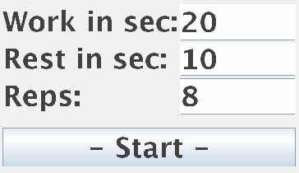
- It is important to have a timer/watch/Tabata application nearby when performing the exercise.
- Also have a water bottle close to regain hydration between intervals.
- It is necessary to decide before beginning what type of results you want; whether it is cardiovascular enhancement, weight loss, muscle gain or many other choices. The workouts chosen each interval must specifically relate to the end goal.
- After the Tabata workout is designed make sure to warm up properly before and stretch before beginning.
- Tabata is a form of high intensity training or high intensity interval training.
- It is important to choose the correct amount of intensity for each interval in order to complete each session.
- If you feel as if you cannot go all out during 1 of the intervals, you may take that 20 seconds to rest or go moderately. But if this is happening more than once, reconsider the exercises in your Tabata and choose accordingly to get through all the intervals pushing your hardest.
- To end the Tabata training end with a cool down and stretch, and of course give your body proper rest and nutrition.
- After a Tabata training session the person will definitely feel the soreness in muscles the next day. You must rest the following day so the body can recover.
Tabata training has proven to work greatly, but there are some disadvantages to be aware of. Because of the high intensity Tabata requires it could be dangerous if someone is prone to strokes or heart attacks. If high blood pressure is known or there is a history of strokes and heart attacks, always consult with a doctor.
In order to be successful while using Tabata training, follow the guidelines and train properly. This is an exceptional way to work out fast, and can be fun!

Unit Performance Task
Water Aerobics 10th grade

By the end of the unit the students will be able to successfully perform four different 4 minute Tabata sessions in the water. The students will use the specific skills taught for the sessions and perform them correctly within the Tabata training and also separately. The students will be able to correctly warm-up/stretch and cool-down/stretch in the water using the movements taught in class. They will understand basic water safety knowledge/rules and proper pool etiquette while in the pool area. The students will also be aware of resources outside of class and how to obtain them if interested in water activities.

Unit Objectives
NYS/NASPE standards

Psychomotor
- 1A/2 - By the end of the unit the students will be able to successfully perform the 4 Tabata training sessions (each 4 minutes long) learned while using the correct technique of water movements.
- 1B/1 - By the end of the unit the students will be able to successfully demonstrate 3 warm-up and 3 cool-down stretches performed in the water using correct form.

Affective
- 2A/5 - By the end of the unit the students will have successfully demonstrated proper pool etiquette by always staying in the space provided during class time and following pool rules.
- 2B/2 - By the end of the unit the students will demonstrate confidence when performing the movement skills taught in water aerobics class.

Cognitive
- 2C/5 - By the end of the unit the students will demonstrate understanding of the pool rules by correctly completing the short T/F quiz.
- 3A/5 - Before the last day of the unit the students will demonstrate knowledge of resources available for water activities by providing me with a website, class schedule, or program of a resource (etc.) that they can use.

Block Plan
Day 1:  Instant Activity: Get used to the water using noodles.  Intro: Introduce myself and short background on water aerobics.  Lesson focus: Introduction to basic water movements and Tabata training.  Fitness component: Balance during warm ups, main activity, and closure. Cardiovascular during Tabata training. Muscular endurance if weights are chosen to be used.  Assessment(s): Self-check using cue cards, teacher observation throughout entire class, and questions asked at end of class.  Closure: CFU – preplanned questions to be asked to see if the students remember some movements taught. Get them excited for this unit by reflecting on how class went. | Day 2:  Instant Activity: Challenge the students with some noodle workouts.  Intro: Reflect on the 6 cue cards we learned about from previous class.  Lesson focus: Repeating the Tabata training from first class. Warm up and closing activities same as first day. Repetition.  Fitness component: Balance during warm ups, main activity, and closure. Cardiovascular during Tabata training. Muscular endurance if weights are chosen to be used.  Assessment(s): Have the class split into pairs, during the first Tabata session for 2 intervals have one partner asses the other. Switch roles.  Closure: Talk about the assessment, if it helped or did not help.
Day 3:  Instant Activity: Begin class with Tabata session #1  Intro: Talk about muscle soreness, healthy nutrition, and rest for the body.  Lesson focus: Treading water in deep end (noodles available) different types of ways to tread water (arms up, down, leg movements)  Fitness component: Cardiovascular while treading water  Assessment(s): Teacher observation on treading water progress  Closure: CFU questions on muscle soreness, nutrition, and rest | Day 4:  Instant Activity: Begin class with Tabata session #2  Intro: Show a quick video clip of a water aerobics class of elders  Lesson focus: Water aerobics is fun for everyone! Music of all types and lots of watch and follow the instructor.  Fitness component: Cardiovascular during main activities, muscular strength when using weights  Assessment(s): End of the class take home assessment to see how the students are feeling about water aerobics thus far  Closure: Talk about benefits of aerobics discussed in first class of unit, see who remembers, try to get them to think about what their bodies have been feeling
Day 5:  Instant Activity: CUE cards for a new Tabata session, practice on own and exchange cards  Intro: quick debrief of today’s lesson, collect assessments from last class  Lesson focus: learning and mastering the new Tabata session. Try putting all three sessions together  Fitness component: Balance during warm ups, main activity, and closure. Cardiovascular during Tabata training. Muscular endurance if weights are chosen to be used.  Assessment(s): Teacher observation during Tabata session  Closure: Discuss about Tabata training. Who thinks it works and why, vise versa | Day 6:  Instant Activity: begin class with Tabata session #3  Intro: discuss the assessments that were handed in last class  Lesson focus: all three Tabata sessions reviewed and repeated. Encourage all students to use weights this time  Fitness component: lots of cardiovascular throughout the Tabata training, muscular strength training if students use weights.  Assessment(s): Have the students in groups of three. During the Tabata sessions have each student be assessing a group member for each session. Take turns on assessing and participating.  Closure: discuss the peer assessments
Day 7:  Instant Activity: Water circle: with weights we will be walking in a circle and pushing the water with our hands creating resistance, change directions and add some movements throughout  Intro: Introduce Zumba, what it is, how we will incorporate it with water  Lesson focus: Zumba water aerobics class. Music and cueing, students will follow along to dance movements.  Fitness component: Balance, reaction time, and flexibility will all be used during the Zumba lesson  Assessment(s): Teacher observation during Zumba to see if the students are enjoying themselves  Closure: Discuss and reflect on today’s lesson | Day 8:  Instant Activity: None today  Intro: None today  Lesson focus: Water aerobics straight through entire class. Be ready with music and have students get right into water. Cue stretches, and all the skills we used in the Tabata training. Cue some dance moves from the Zumba lesson. Cue some new skills. Keep moving entire class period.  Fitness component: Cardiovascular, muscular strength, muscular endurance, flexibility, balance and coordination  Assessment(s): Take home quiz on the 3 Tabata trainings we learned  Closure: Discuss and reflect on today’s lesson
Day 9:  Instant Activity: Tabata session #1  Intro: Have students discuss and present what they would like to do in class today. Totally up to students  Lesson focus: Totally up to students – must be in water and active.  Fitness component: up to students  Assessment(s): Teacher observation on how well the students can agree on an activity  Closure: Ask students what they learned with their choice of activity today. | Day 10:  Instant Activity: Tabata session #2  Intro: quick debrief of today’s lesson  Lesson focus: Learn a new Tabata session with 4 new water aerobics movements that the students have not yet learned. Put all sessions together and repeat  Fitness component: lots of cardiovascular throughout the Tabata training, muscular strength training if students use weights.  Assessment(s): After the students have learned and practiced the Tabata session #4, step aside, ask for a volunteer to lead, if no one will have them continue anyways putting all 4 sessions together. Observe on the side with a checklist to see how each student is doing.  Closure: Hand out the checklist to the student and have them bring back a reflection on how they think they are doing
Day 11:  Instant Activity: Tabata session #3  Intro: Reflect on weight training unit  Lesson focus: Utilizing water resistance in the water. Learning to pull, push, and resist as much as possible  Fitness component: Muscular strength  Assessment(s): Teacher observation during the Tabata session #3  Closure: Collect reflections, next class is our last, be ready to perform certain skills. | Day 12:  Instant Activity: Tabata session #4  Intro: Discuss the skills that I will be observing for end of the unit performance test  Lesson focus: While the students perform the 4 Tabata sessions learned and practiced, teacher will be skill testing to ensure proper technique is used and skill is known.  Fitness component: Cardiovascular during Tabata training. Muscular endurance if weights are chosen to be used.  Assessment(s): Teacher assessment during class, performance task checklist  Closure: Give students their task sheet. Discuss water aerobics benefits. Debrief on how the students felt about this unit.

Activity Progression
Skill(s): WATER AEROBICS: TABATA TRAINING
MOST COMPLEX SKILL
 | Tasks (Extensions)  The activities for the whole class | Cues (Refinements)  Secrets to improve performance | Challenges (Applications)  More chances to practice the same tasks
1 | Tabata sessions 1 & 2 with normal timed break in between | Yellow=prepare  Green=GO HARD  Red=rest | Use weights
2 | Tabata sessions 1 & 2 with extended break in between | Yellow=prepare  Green=GO HARD  Red=rest | Use weights
3 | Tabata training session #2 | Yellow=prepare  Green=GO HARD  Red=rest | Use weights
4 | Tabata training session #1 | Yellow=prepare  Green=GO HARD  Red=rest | Use weights
5 | Straight leg kicks to the right in water | Push down  STRAIGHT | Put arms into motion as well
6 | Straight leg kicks to the left in water | Push down  STRAIGHT | Put arms into motion as well
7 | Straight leg kicks to the right on land | Maintain balance | Put arms into motion as well
8 | Straight leg kicks to the left on land | Maintain balance | Put arms into motion as well
9 | Backward lunge in water | Knee in line with ankle | Use weights
10 | Backward lunge on land | Knee in line with ankle | Use weights
11 | Boxer in water | Left left, right right | Use weights
12 | Boxer on land | Left left, right right | Use weights
13 | Straight leg kicks to front in water | Straight | Put arms into motion as well
14 | Straight leg kicks to front on land | Straight | Put arms into motion as well (teacher will be doing the leg kicks and arm movements however the focus is the leg, if the leg movement is mastered they may try to follow along with arms)
15 | Tuck jumps in water | Knees to chest | Use weights
16 | Tuck jumps on land | Knees to chest | Use weights
17 | Front squats in water | Knee in line with ankle | Use weights
18 | Front squats on land | Knee in line with ankle | Use weights
19 | Balance on a noodle handless | Squeeze abdominals | Count to 10 seconds
20 | Balance on a noodle | Squeeze abdominals | Count to 10 seconds
21 | Jumping up and down in water | Push through toes | Use weights
22 | Jumping Jacks in water | Slow | Use weights
23 | Fast bob to high knees | Fast and high | Use weights
24 | Slow bob to high knees | Slow and high | Use weights
25 | Fast bob to low knees | Fast and low | Use weights
26 | Slow bob to low knees | Slow and low | Use weights
27 | High knees in water | High | Use weights
28 | Low knees in water | Low | Use weights
29 | Fast bob in water, weight transfer | One foot to the other | Use weights
30 | Slow bob in water, weight transfer | One foot to the other | Use weights

Lesson Plan  of | NYS/NASPE  Standards | Teacher Candidates: Beka Fredrickson | School: SUNY Cortland | Date: 11/14/11  Grade: 10th  # in class: 15
Bold Teaching Style: Command Practice Reciprocal Self-Check Guided Discovery
Inclusion Convergent Divergent Jigsaw Cooperative
Domains |  | Objectives (Be sure to include Situation, Task and Criteria for each objective) | Assessment Tool &  When it is used | Length of class: 45 minutes
Psychomotor | 1A / 2 | During the Tabata training the students will be able to correctly perform the basic water aerobics skills they practiced from the cue cards for the full 4 minutes. | Peer checklist on skills | Unit: Water Aerobics  Focus: Introduction, basic movements, Tabata Training
Affective | 2A / 5 | Throughout the entire class the students will display responsibility, attentiveness, and proper pool etiquette by obeying the class rules posted. | Student reflection on Hellison’s chart end of class | Equipment: 30 water weights, 15 noodles, 2 water floaters, microphone head set, speakers, iPad, music
Cognitive | 1A / 2 | By the end of the class the students will show understanding by correctly naming a type of water aerobics skill taught in class when called upon. | Questions at the end of class | References:  (1) http://www.ifafitness.com/book/aqua.htm  (2)http://www.youtube.com/watch?v=bdru_-coIYU&NR=1  (3)http://tabatatraining.org/
Safety Statement |  | The students will be safe by not entering the pool until I am present and a lifeguard is present. They will stay in the shallow end unless permission is permitted. | Observation and enforcement by teacher throughout the whole class
NYS Learning Standard 1 – Personal Health and Fitness  1A. Students will perform basic motor and manipulative skills. Students will attain competency in a variety of motor and sports activities.  1B. Students will design personal fitness programs to improve cardio respiratory endurance, flexibility, muscular strength, endurance, and body composition  NYS Learning Standard 2– A Safe and Healthy Environment  2a. Students will demonstrate responsible personal and social behavior while engaged in physical activity.  2b. Students will understand that physical activity provides the opportunity for enjoyment, challenge, self-expression and communication.  2c. Students will be able to identify safety hazards and react effectively to ensure a safe and positive experience for all participants.  NYS Learning Standard 3– Resource Management  3a. Students will be aware of and able to access opportunities available to them within their community to engage in physical activity.  3b. Students will be informed consumers and be able to evaluate facilities and programs.  3c. Students will also be aware of career options in the field of physical fitness and sports |  |  | NASPE Content Standards – A physically educated person:  1. Demonstrates competency in motor skills and movement patterns needed to perform a variety of physical activities.  2. Demonstrates understanding of movement concepts, principles, strategies and tactics as they apply to the learning and performance of physical activities.  3. Participates regularly in physical activity.  4. Achieves and maintains a health-enhancing level of physical fitness.  5. Exhibits responsible personal and social behavior that respects self and others in physical activity settings.  6. Values physical activity for health, enjoyment, challenge, self-expression, and/or social interaction

What is the ongoing fitness theme or emphasis in this lesson?
Health-related Fitness (HRF)  NYS LS 1B  (Please Bold)  Cardiovascular endurance Muscular strength  Muscular endurance Flexibility  Body composition | Cardiovascular endurance: While the students are in the water they will use cardiovascular endurance by moving in multiple different directions increasing their heart rate.  Muscular Strength: During a main activity the students have the choice of using weights to increase muscular strength and increase resistance.  Flexibility: All movements in the class will work on flexibility do to long arm, leg, and torso movements. | Skill-related Fitness (SRF)  NYS LS 1A  (Please Bold)  Balance Coordination  Agility  Reaction time  Speed  Power | Balance: During the warm up and closure the students will all be performing movements on one leg or a noodle. This will incorporate balance in order to stay above the water.  Coordination: In order to perform water aerobics the class must be able to follow my instructions and demonstrations which will include good coordination or moving while watching and listening.

Lesson Components | Time (mins) | Organization &  Transitions | Description |  |  |  | Adaptations Assessments, Reminders
Instant Activity | 5 min | T  x x x x x  x x x x x  x x x x x | -Have all students get into the water – shallow end only  -Have them take a noodle  -Let them warm up to the water and swim around with the noodle (music playing)  -Tell them to try and balance sitting on the noodle – if this is easy for them tell them to try to keep their arms and hands above the water while balancing |  |  |  | NO deep end, make sure all students are safe to swim and comfortable.
Introduction, Signal for Attention,  Hook | 2 min | T  xxx xxx  xxxx xxx x x | -Gather students over towards the deck and be sitting close so they can hear.  -Hello class my name is Ms. F and today we are starting our water aerobics class!  -Water aerobics offers people an exercise that puts no stress on joints.  -This is an exercise that is low-impact, but still gives great health benefits.  -Who here can guess how much of our body’s weight is supported while standing in the water? (85-90%)  -The average person burns 450-700 calories while working out in the water.  -Today we will need to pay close attention to my instructions in order to stay together and be safe.  -If I need to gain your attention I will blow my whistle and I want you all to stop what you’re doing and look up at me.  -Amy what are you supposed to do when I blow my whistle?  -For safety you all need to remember we cannot run on the deck, it is wet and slippery! Please be careful. While in the water stay in the shallow end at all times and use equipment with best judgment according to your own ability.  -Kevin how can be safe today?  -Alright everyone spread out into your own space, and make sure you can see me! |  |  |  | Wait until all students are over and ready to listen.  CFU
Demonstration |  | T  x x x  x x x  x x x x  x x  x x x | -ACTIVE DEMONSTRATION  Demonstration will be done consistently throughout all activities listen below. Watch and follow along. If a student has a question about the cue cards handed out, I will demonstrate the movement on the deck.
Body of Lesson  (Lesson Focus) |  |  | Teaching Progressions – Show some of the major tasks/activities listed on your Activity Progression Worksheet within the selected level of (PC/C/U/P) for the class.
 |  |  | Tasks (Extensions) - Activities for the whole class. E.g. Hit the ball over the net to your partner 10 times. | Cues (Refinements) – Simple secrets to improve performance. E.g. Low to high | Challenges (Applications) - More game-like chances to practice the same tasks at the same difficulty level. E.g. In 90 seconds, see how many times you can hit the ball to your partner. | Modifications –  Add modifications to make the tasks easier and harder according to the skill level of the students. | Adaptations Assessments, Reminders
 | 6 min | T  x x x  x x x  x x x x  x x  x x x | 1. WARMING UP & STRETCHING Students follow along with instructor.  -Waist bender (hold onto pool rim with one hand, extend left arm overhead, step out with left foot, bending your body to the right and reaching to the pool rim, repeat both sides)  -Round the clock (extend both arms out about shoulder height palms down, circle arms in circles both small and large, forward and back)  -The bouncer (stand with feet together, legs slightly bent, and arms by legs palms in. Bounce up on the left foot pushing down against water with both hands, causing body to rise up, reverse and bounce on right foot)  -High leg swing (students may choose whether to hold onto the pool rim with one arm or try and balance without holding. Swing one leg forward and back in a high full arc. Repeat both sides)  -Figure 8 (pull in stomach muscles and move your arms in an 8 figure motion at the sides of the body pushing against resistance of water. Students may use weights if they want)  INCLUSION TEACHING – student’s choice of -  High level: choose to perform each skill without a noodle or holding onto the wall. May use weights  Lower level: Using pool wall or noodle for balance. | 1. Slow, controlled, stretch | 1. There will be weights available for the students to use if they want to increase resistance. There will also be challenges for the students to try tasks without holding onto the rim of the pool. | Easier – Slow everything down and cue to 2 hold counts. Turn music down very low and talk them through each movement.  Harder - Let the students cue themselves and see if they can stay matched up to me. | Make sure each student can swim, if not have a noodle always available. Ensure safety at all times. Teacher observation, watch to see how they are catching on to determine how the lesson will go.
 | 3 min  12 mins | T  x x x  x x x  x x x x  x x  x x x | 2. -Have the students choose a CUE card; each card will have one of the Tabata movements listed on them.  -Explain to each student that they must try to do the movement, then exchange for another card.  -Collect the cards and briefly talk about Tabata training, new founded research training method  -Yellow we prepare, green we go ALL out, red we rest in place  -Weights may be used to increase resistance  -Use inclusion teaching here by letting them choose to use weights, and tell them they may modify an exercise if it is too hard, but must always keep moving.  -TABATA SESSION #1: 4 minutes  Front Squats (intervals 1,3)  Tuck Jumps (intervals 2,4)  Straight leg kicks to front (5,7)  Boxer (6,8)  -Have everyone take a lap walking around the perimeter of the space we are using to catch their breath. Regain attention and have students get back into their own space: 2 minutes  -TABATA SESSION #2: 4 minutes  Backward Lunge (intervals 1,3)  Tuck Jumps (intervals 2,4)  Straight leg kicks to sides R/L (5r,7l)  Boxer (6,8)  -Have the students walk around the pool shallow end. Let them get out and take a fast drink and return to the water. After 30 seconds give them a 10 second warning to get back into the pool in their own space: 2 minutes | Yellow=prepare  Green=Work HARD  Red=Rest | 2. Weights to increase resistance. Noodles to help balance. Wall may be used to help balance. No break in between sessions if students are not looking tired at all. | Easier – Make it 10 seconds all out and 20 seconds as the break  Harder - Make it to be 30 seconds all out and 10 seconds break. Have students increase weights. | Make sure to use a weight appropriate to go all out for all 8 intervals. The exercises should be hard enough to makes students sweat and breathe during an interval, however easy enough so you can last the whole Tabata session.
 | 9 min | T  x x x  x x x  x x x x  x x  x x x | 3. -NOODLE WORKOUTS: 9 minutes  Start with the noodle wrapped around the front chest and under each arm, supporting the body.  -Leg Circle (bring both legs up horizontal to the floor, as high as possible, make a circle by pushing them out and around landing behind, tuck legs under to beginning position.)  -V Ups (start like last movement and spread legs to a straddle position and reach hands towards the middle, pull legs back in together)  -Leg Push (again starting with legs up straight out in front, bend and bring knees to the chest and follow through by pushing them out to beginning position)  -Step taps (start with the feet together and lunge to the right, bring foot back in to tap at the middle, both sides) | 3.  -Balance  -Resistance  -Head up | 3. Let the students count for themselves. Continue to do each motion the correct amount of times, but switch sides or activities and have students practice following along. | Easier – Choose only 2 of these activities and break it down very slowly.  Harder – Tell the students they can drop the noodle and try to balance without it, and possibly use weights if they want. | This is a great time for peer assessments. Have one student asses while one student follows and then switch half way through.
 | 4 min | T  x x x  x x x  x x x x  x x  x x x | 4. COOLING DOWN & STRETCHING  -Repeat same activities as in 1 | 4. Slow, controlled, stretch | 4. If any student feels comfortable to call out some 8 counts while doing these closing activities have them try it out. | Easier – Slow everything down and cue to 2 hold counts. Turn music down very low and talk them through each movement.  Harder - Let the students cue themselves and see if they can stay matched up to me. | Teacher observation to ensure proper technique.
Activity close (Optional) | 2 min |  | Have all students get out of the pool while grabbing any materials used in class from pool. All students must help put equipment away safely.
Lesson Closure,  Hook to Next Lesson | 2 min |  | -Everyone did an awesome job today I am really impressed! I hope it was fun for you all, I sure enjoyed it.  -McKenna can you name two types of movements we learned today?(If not the name, have them describe or demonstrate the movement)  -Cassie can you name two different types of movements we learned today?  -Lindsay can you tell me one benefit of water aerobics you felt your body obtain during the lesson today?  -Okay class looks like we are right on track for next class, we will continue with these basic movements, and hopefully pick up the speed of the music!  -Come ready to have lots of fun next class!
Evaluation of Lesson | Pre-planning: Previous instruction in this activity (earlier grade levels)  Post-planning: “Assessment Informs Teaching:” future needs based on assessment results  Teacher Reflection Notes:

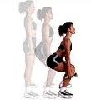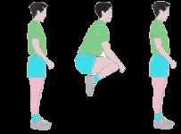
FRONT SQUATS TUCK JUMPS
Stand tall in the water with feet shoulder width Stand tall in the water with feet together.
apart & looking forward the whole time. Bend Bring both legs up to waist level by
legs 90 degrees forcing all weight to the heels. jumping. Try to push your arms down to
Keep your knees in line with the ankles. Make your sides (not shown in picture) to create
sure the knees do not pass over the feet! water resistance in the arms as well. Try
Stand back up. Try this 3 times then exchange this 3 times then exchange cards. *You
cards. *You may use weights to increase resistance. may use weights to increase resistance.

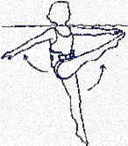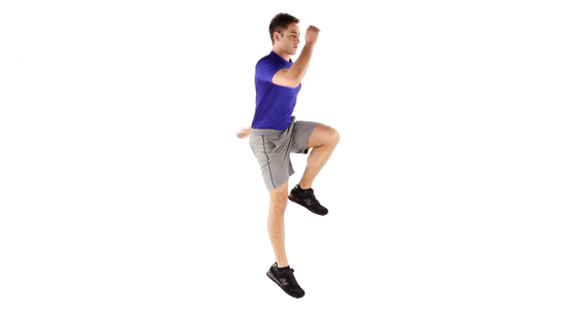
STRAIGHT LEG KICK TO FRONT THE BOXER
Stand tall with feet together and arms out Begin with both legs flat in the water.
to the sides for balance. Bring one leg straight Hop twice on the left foot, then twice
up to the front of your body as high as possible. on the right foot. Keep the knee that is
Keep the other leg planted to the ground. Pull up at a decent level, not to low or high.
the leg back down to your other leg keeping it Try this a few times then exchange cards
straight the whole time. Try both legs 3 times *Add opposite arm/leg movement to
each then exchange cards. *A noodle may be increase difficulty.
used under the arms to help balance.
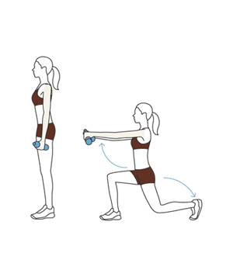
BACKWARD LUNGE STRAIGHT LEG KICK TO THE SIDE
Stand tall in water with feet together. Stand tall in the water with feet together.
Bring one leg straight back behind you Keeping your leg straight the whole time,
bending to get the knee close to the bring the leg up to side of your body as high
floor. Create a 90 degree bend with the as possible. Pull that leg back down to your
other leg. Use your toes to push back other leg. Try both sides then exchange cards.
forward. Make a wide space when you *You may hold onto side wall of pool to
go backward. Do not let front knee go keep balance. Hold weights in hands to
over the foot. Try both legs 3 times then increase difficulty.
exchange cards. *You may bring arms up
while lunging to increase water resistance
in the arms. Weights will also increase
resistance.

Psychomotor Assessment
Day 1 Water Aerobics

Objective: During the Tabata training the students will be able to correctly perform the basic water aerobics skills they practiced from the cue cards for the full 4 minutes.

NYS/NASPE Standards: 1A/2

Grade: 10th

End of the Class Student Self Checklist

Name: | YES | NO
Movement for full 4 minutes

Follows the Tabata Training actions
-20 seconds full movement
-10 second of rest (light bob)

Proper form – front squats/backward lunges
-Knees in line with ankles
-Full squat 90 degree

Proper form – kicks (front and side)
-Legs must be straight, low and straight is better than high and bent
-Were you balanced?

Proper form – tuck jumps
-Knees to waist level or higher
-Were you jumping?

Proper form – Boxer
-Two hops on the left foot with right foot bent then switched
-Knee up at decent level not too high or low

Affective Assessment
Day 1 Water Aerobics

Objective: Throughout the entire class the students will display responsibility, attentiveness, and proper pool etiquette by obeying the class rules posted.

NYS/NASPE Standards: 2A/5

Grade: 10th

Name_________________

Using the chart below, please reflect on what level you think you were during the lesson today.
Hellison's Five Levels
The Hellison 5:  Where you at? | Level 1:  Irresponsible  - Blames others  - Name calling  - Disruptive  - Negative  - Makes excuses  - Does not play by the rules  - Aggressive behavior  - Does not listen or participate | Level 2:  Self Control  - Does not call names  - Controls temper  - Does not disrupt class  - Listens, but does not actively participate  - Really does not put forth any effort  - Cruising in neutral, but not bothering anybody
Level 3:  Involvement  - Listens and follows direction  - Shows at least minimal respect  - Stays on task only when teacher is watching  - Willing to try and are involved in activities  - Participates with reservation | Level 4:  Self-Responsibility  - Shows respect  - Makes good choices  - Honest and fair  - Admits mistakes and apologizes  - Works on activities independent of teachers  - Works with other to settle argument quickly | Level 5  Caring  - Exhibits all of level four  - Works with everyone in the class willingly  - Compliments and encourages others  - Takes care of equipment  - Asks and provides assistance to teacher and other student  - Concerned with the progress of others
Cognitive Assessment
Day 1 Water Aerobics

Objective: By the end of the class the students will show understanding by correctly naming a type of water aerobics skill taught in class when called upon.

NYS/NASPE Standards: 1A/2

Grade: 10th

End questions to ask

- Please name 2 movement skills we learned today
-Acceptable answers: Front squats, tuck jumps, straight leg kicks to front, the boxer, backward lung, straight leg kicks to the side
- Describe the 2 movement skills just listed from your classmate
-Use cue cards to check answers
- Please name 2 different movement skills we learned today
- Describe those 2 movement skills

